A Python-based Image Processing Toolkit

Analysis of the Problem

Description of Problem

The purpose of this project is to create a Python-based Image Processing Toolkit with which the user can select an image from their device and apply a number of useful filters to it. I plan to include the following filters: sharpen, low-light enhancement, error diffusion and a median filter. I intend for the user to be able to change parameters of these filters, such as the number of iterations or the strength of the filters. The user will be able to select a different image to edit. They will also have the option to save the image to their device and upload it to a webpage.

For this project, the target end users are high school students in S5 or S6 who have an interest in image processing.

My project meets the Advanced Higher computing requirements as it is a procedural program which contains 2D arrays (The images would be converted into arrays). My project uses the bubble sort algorithm to order a list of integers as this is needed for the median filter. My project also allows users to upload the image they are editing to a webpage, where the image is displayed.

Scope

The project will include:

* A completed design with pseudocode of the algorithms used, as well as a wireframe of the GUI and the webpage.
* A working image processing toolkit that incorporates AH computing concepts and connects to a webpage.
* Plans for final testing, with a description of the test cases.
* Evidence of the testing as well as the results.
* Persona testing.
* An evaluation report of the completed project.

Constraints

The following constraints are applied to the project:

* Python (version 3.8.8) will be used as I have experience in that language, it has a wide range of image processing libraries, and it has easy to use syntax.
* The developed toolkit will be developed and tested on macOS Big Sur using the IDE Visual Studio Code.
* The webpage will be stored as an HTML file on the user's device.
* There will be no costs, as all the materials and equipment I am using are provided by the school or free to access.
* I will ensure that the project is completed and submitted by the SQA deadline.

Boundaries

My working solution will contain the following boundaries:

* When selecting an image, the user will only be able to select a file with one of the following file types: PNG, JPG, BMP.
* The user will only be able to select a file from their device
* The Image Processing Toolkit will only be able to work with one image at a time.
* The sharpen and low-light enhancement filters will give a minimum number of iterations of 1 and a maximum number of iterations of 5.
* The sharpen and low-light enhancement filters will have a minimum strength of 1 and a maximum strength of 20.
* The program will not allow the user to choose the file type when saving the image.

End User Requirements

I have conducted a survey by asking potential end users what features they would like an image editor to have. Their requirements are summarized below.

* An easy to use, clean user interface, which displays the image that is being edited.
* The option to save the image to your device.
* The option to upload the image to a website.
* A filter which enhances low light images.
* A filter which removes noise from noisy images.

Use Case Diagram

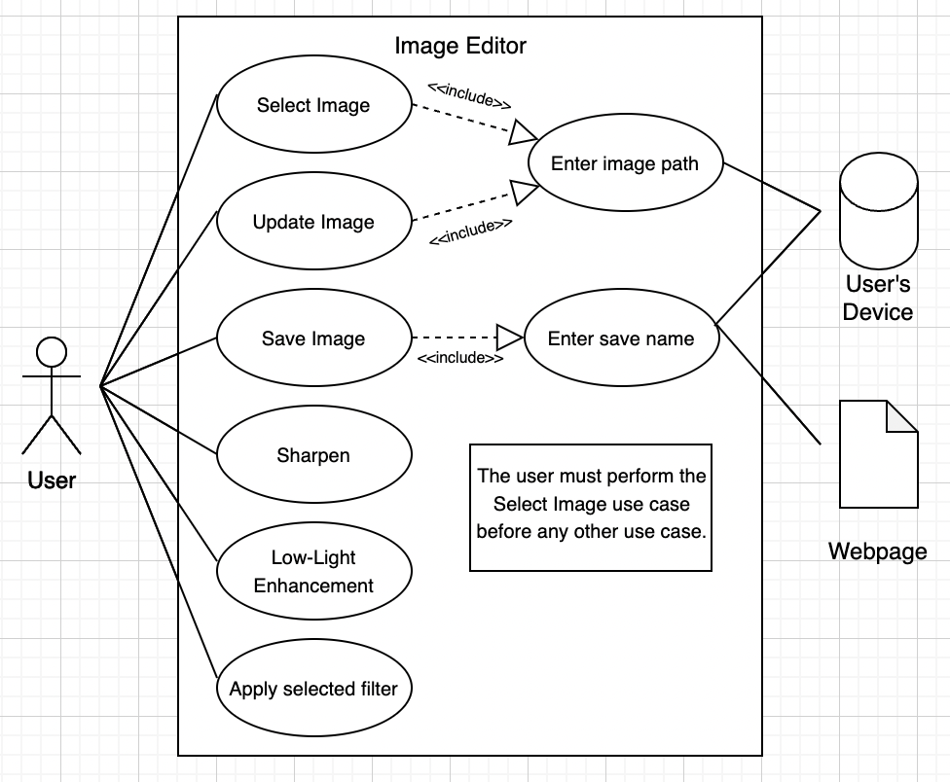

Requirement Specification

**My system will meet the following criteria**

The program will be composed of four windows between which the user can navigate. Each window will have its own requirements.

When the system is launched, it writes the current date to an HTML file. The Select Image window opens

**Select Image Window Requirements**

Users can select an image from their computer to edit using the toolkit.

* 1. The Select Image window appears, where the user is prompted to enter the path of the image they want to select.
  2. The Select Image window allows the user to enter the path of the image they want to select.
  3. After the user presses the Enter button validation runs to check if the path the user entered exists and if the path leads to an image file.

If the path is not an existing file:

A message telling the user that the path is invalid appears.

If the path is an existing file but not an image file:

A message telling the user that the file type is incorrect appears.

If the path is an existing image file:

The Select Image window closes. The Main window opens, displaying the selected image.

**Main Window Requirements**

* 1. The Main window displays the image selected in the Select Image window. The image is scaled down if the image’s width or height is greater than 500 pixels.
  2. The Main window displays the following buttons: Sharpen, Low-Light Enhancement, Apply Selected Filter, Save Image, Update Image, Quit. The Main window also displays a Select Sharpening Strength slider, a Select Low-Light Enhancement Strength, a Select number of iterations slider and a dropdown menu where the user can choose between Error Diffusion and Median Filter.
  3. The user can change multiple parameters for the Sharpen and Low-Light Enhancement filters using sliders. The Main window will have the following sliders:

**Select Sharpening Strength:** This slider has a minimum value of 1 and a maximum value of 20 and affects the Sharpen filter’s strength. The higher the value selected, the greater the strength of the filter.

**Select Low-Light Enhancement Strength:** This slider has a minimum value of 1 and a maximum value of 20 and affects the Low-Light Enhancement filter’s strength. The higher the value selected, the greater the strength of the filter.

**Select number of iterations:** This slider has a minimum value of 1 and a maximum value of 5 and selects how many times the algorithms of the Sharpen and Low-Light Enhancement filters run.

* 1. The Sharpen filter can be applied to the image being shown in the Main window by clicking the Sharpen button. The image is sharpened. The filtered image is displayed in the Main window.

* 1. The Low-Light Enhancement filter can be applied to the image being shown in the Main window by clicking the Low-Light Enhancement button. The dark parts of the image are intensified. The filtered image is displayed in the Main window.
  2. The Error Diffusion filter can be applied to the image being shown in the Main window by selecting Error Diffusion in the drop-down menu, then clicking the Apply Selected Filter button. The image is converted into a binary image. The filtered image is displayed in the Main window.
  3. The Median filter can be applied to the image being shown in the Main window by selecting Median Filter in the drop-down menu, then clicking the Apply Selected Filter button. The image becomes less noisy. The filtered image is displayed in the Main window.
  4. When the Save Image button is clicked, the Save Image window opens.
  5. When the Update Image button is clicked, the Update Image window opens.
  6. When the Quit button is clicked, the program ends.

**Save Image Window Requirements**

Users can save the image that is being displayed in the Main window.

* 1. When the Save Image button is clicked, the Save Image window appears, where the user is prompted to enter under what name they want to save the image.
  2. The Save Image window allows the user to enter under what name they want to save the image.
  3. When the enter button is clicked:
     1. The image is saved as a PNG file to the user’s device under the name selected by the user.
     2. The image is saved to the HTML file that was written to when the program was started.
     3. The Save Window closes.

**Update Image Window Requirements**

Users can choose a new image to edit from. their device.

* 1. When the Update Image button is clicked, the Update Image window appears, where the user is prompted to enter the path of the image they want to select.
  2. The Update Image window allows the user to enter the path of the image they want to select.
  3. After the user presses the Enter button validation runs to check if the path the user entered exists and if the path leads to an image file.

If the path is not an existing file:

A message telling the user that the path is invalid appears.

If the path is an existing file but not an image file:

A message telling the user that the file type is incorrect appears.

If the path is an existing image file:

The Update Image window closes. The selected image is scaled down if the image’s width or height is greater than 500 pixels. This image is displayed in the Main window.

**Webpage Requirements:**

When an image is saved to the user’s device, it is also displayed on a webpage.

The image is saved to the HTML file that was written to when the program was started. The image is displayed on the webpage under the date when it was saved.

Project Plan

|  |  |  |  |
| --- | --- | --- | --- |
| Task | Sub-Task | Duration | Target Start Date |
| Analysis | Read AH Computer Science requirements and develop ideas | 2 days | November 2nd |
| Project description, scope, boundaries, and constraints | 1 day | November 8th |
| End User Requirements | 1 day | November 9th |
| Functional Requirements | 2 days | November 11th |
| Use Case Diagram | 1 day | November 15th |
| Project Plan | 1 day | November 16th |
| Design | Wireframes | 3 days | November 22nd |
| Pseudocode | 7 days | November 29th |
| Implementation | Sharpen filter | 6 days | December 10th |
| Low-Light Enhancement filter | 3 days | January 10th |
| Error Diffusion filter | 4 days | January 17th |
| Median filter | 4 days | January 21st |
| Bubble sort algorithm | 2 days | January 31st |
| Sliders | 2 days | February 3rd |
| Select Image | 2 days | February 10th |
| Update Image | 1 day | February 11th |
| Select Image and Update Image validation | 2 days | February 21st |
| Save Image | 1 day | February 25th |
| User Interface | 3 days | March 3rd |
| HTML | 1 day | March 4th |
| Bug Fixing | 1 days | March 7th |
| Research of new skills | 1 day | March 8th |
| Log of ongoing testing | 1 day | March 9th |
| Testing | Creating test data | 1 days | March 10th |
| Testing using test data | 3 days | March 14th |
| Persona testing | 1 day | March 18th |
| Evaluation | Fitness for purpose | 1 day | March 21st |
| Maintainability | 1 day | March 22nd |
| Robustness | 1 day | March 23rd |

Resources Used

|  |  |
| --- | --- |
| Analysis | Microsoft Office Word  Draw.io |
| Design | Microsoft Office Word  Draw.io  Error diffusion:  Author: Alasdair McAndrew  Title: An Introduction to Digital Image Processing with MATLAB  Publisher: Course Technology  Year: 2004  Adaptive image smoothing for low-light enhancing:  Author: Stan Birchfield  Image Processing and Analysis  Publisher: Cengage Learning  Year: 2017 |
| Implementation | Visual Studio Code  Python 3.8.8  <https://docs.python.org/3/library/tkinter.html>  <https://pillow.readthedocs.io/en/latest/handbook/index.html>  <https://numpy.org/doc/stable/user/absolute_beginners.html>  https://stackoverflow.com/ |
| Testing | Microsoft Office Word |
| Evaluation | Microsoft Office Word |

Design of the Toolkit

GUI Design

The GUI will consist of 4 windows between which the user can navigate:

* A Select Image window.
* A Save Image window.
* A Main window.
* An Update Image window.

**User Input windows**

The Select Image, Save Image and Update Image windows have similar designs. They each contain a message, an input box and an enter button. They have a white background and are not resizable.

These windows would be used to take in input from the user. They would disappear after the enter button has been clicked.

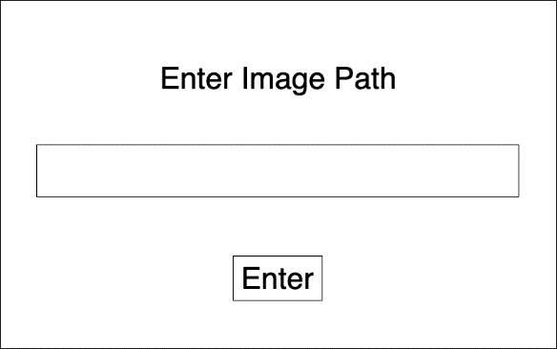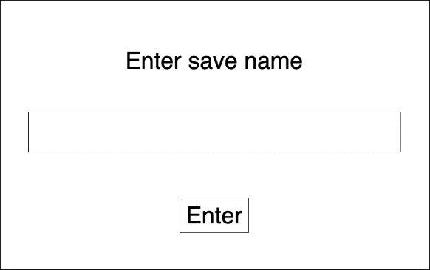 **Select Image window Save Image window**



**Update Image window**

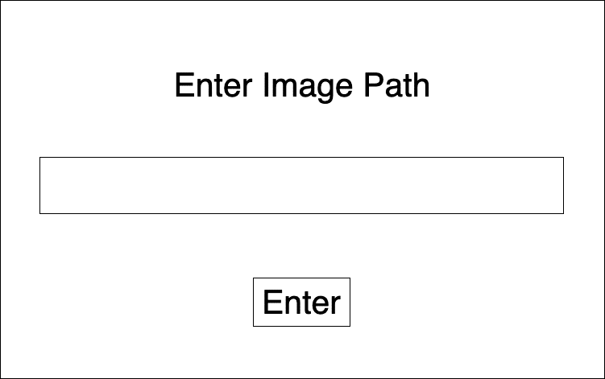

**Failed Validation**

If validation has been failed for the user input, the Select Image or Update Image windows will update their message depending on what validation has been failed.

**Non-existent path message Invalid file type message**

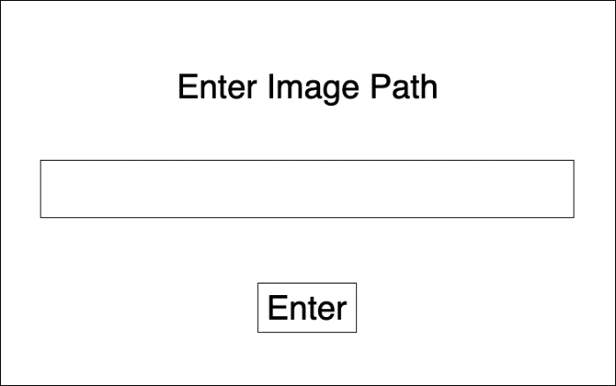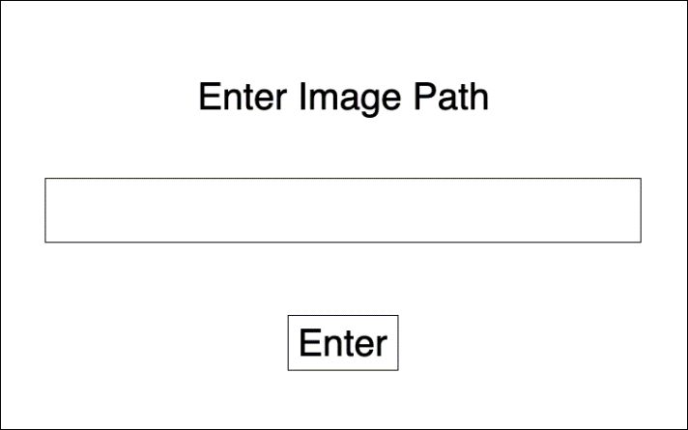

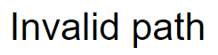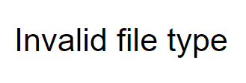

**Toolkit GUI**

The Main window displays the actual toolkit. The Main window displays the image that the user is working with at all times. It will update the image when the image is changed by the user, or a filter is applied.

The Main window has a white background and is not resizable.

This window would be used by the user to apply filters to images and view the results.

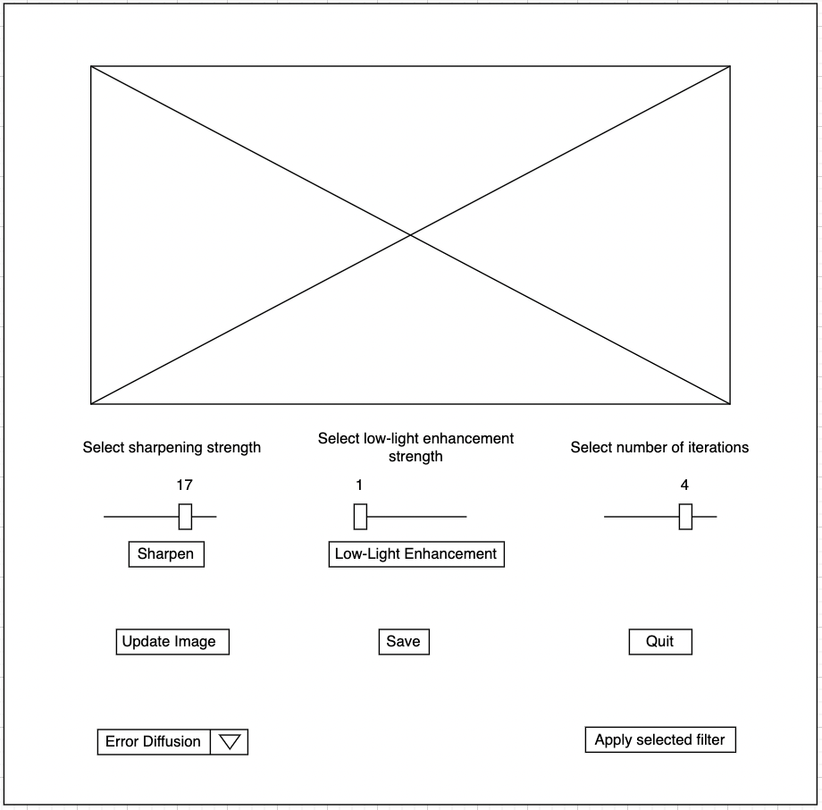 **Main window**

Webpage Design

**Webpage wireframe**

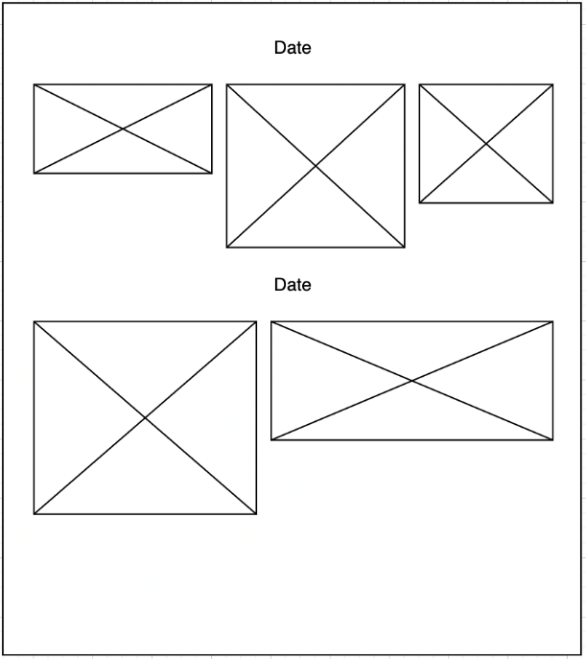The background is light yellow, and the date is centered.

As new images are added, they will appear from left to right. If there is no more room in a row, the image will appear on a new line. Each image will appear underneath the date when the image was saved.

Design of Concepts

The filters will be applied by first converting the image used into a 3d array, which will be further split into 3 2d arrays. (A 2d array for each color channel). An algorithm will be applied to each 2d array. The 2d arrays will be converted back into a 3d array which is converted back to an image. This would result in a filtered image.

Each value in the array represents an RGB value. The values in the array can be changed depending on their surrounding values in the 2d array to apply a filter.

Nested loops are used to go through the values in the 2d array. The border values are not included in this loop.

1. rows = image width
2. columns = image height
3. loop for x (1, rows-1)
4. loop for y (1, cols-1)

Nested loops also used to go through all the values in a 3x3 grid in the 2d array.

1. loop for i (-1, 2)
2. loop for j (-1,2)

Design of filters

The Sharpen Image and Low-Light Enhancement filters are applied by first converting the image that is being edited into three 2d arrays, one for each color channel. They store each pixel’s red, green, or blue value. The image processing algorithm is then applied, and the three arrays are converted back into an image to be displayed.

**Sharpen Image**

The sharpen filter uses the unsharp masking technique to sharpen images. The image is first blurred using the box blur technique, then the blurred image is taken away from the original image. This is multiplied by a value given by the user and added onto the original image, resulting in a sharper image.

**Pseudocode**

1. def method sharpen
2. scale = sharpenSlider value
3. cols, rows = img width, img height
4. arrayA = img as array
5. endArray = img as array
6. loop k for each colour channel
7. loop for number of iterations selected by user
8. arrayB = empty array same size as img array

//loops through all values in array except boundary elements

1. loop for x (1, rows-1)
2. loop for y (1, cols-1)

//loops through 3x3 grid in array

1. loop for i (-1, 2)
2. loop for j (-1,2)
3. arrayB(x,y) = arrayB(x,y) + arrayA(x+i,y+j)
4. end loop
5. end loop

//mean pixel value is calculated for surrounding pixels

1. arrayB(x,y) = arrayB(x,y)/9
2. end loop
3. end loop
4. arrayA(colour channel k) = arrayB
5. end loop
6. end loop
7. endArray = endArray + scale*(endArray – arrayA)

//values that are too big or too small are cut off

1. set values in endArray that are greater than 255 to 255
2. set values in endArray that are less than 0 to 0
3. convert endArray to image finalImg
4. display finalImg in root
5. img = finalImg

**Low-Light Enhancement**

The Low-Light Enhancement filter improves the lighting in images with bad lighting. It detects the darker parts of the image and intensifies them to be just as bright as the rest of the image, resulting in an image with improved lighting.

**Pseudocode**

1. def method enhance
2. scale = enhanceSlider value
3. cols, rows = img width, img height
4. arrayA = img as array
5. loop k for each colour channel
6. loop for number of iterations selected by user

//loops through all values in array except boundary elements

1. loop for x (1, rows-1)
2. loop for y (1, cols-1)
3. w = 0
4. wSum = 0

//loops through 3x3 grid in array

1. loop for i (-1, 2)
2. loop for j (-1, 2)
3. w = exponent(-scale*absoluteValue(arrayA(x+i, y+j ,l) - arrayA(x,y,l)))
4. arrayB(x,y) = arrayB(x,y) + arrayA(x+i, y+j, l)*w
5. wSum = wSum +w
6. end loop
7. end loop
8. arrayB(x,y) = arrayB(x,y)/wSum
9. end loop
10. end loop
11. arrayA(colour channel k) = arrayB
12. end loop
13. end loop
14. endArray = copy(arrayA)
15. endArray = arrayA/(endArray + 0.1)

//values that are too big or too small are cut off

1. set values in endArray that are greater than 255 to 255
2. set values in endArray that are less than 0 to 0
3. convert endArray to image finalImg
4. display finalImg in root
5. img = finalImg

The Error Diffusion and Median filters are applied by first converting the image to grayscale, and then into a 2d array. The array stores how light or dark every pixel is. The image processing algorithm is applied to the array, which is converted back from an array into an image to be displayed.

**Error Diffusion**

The error diffusion filter converts the image to a binary image. A binary image is an image which consists of only black and white pixels. The algorithm decides whether a pixel is black or white based on the density of the surrounding pixels.

This filter can be used to conserve ink during printing as a binary image uses up less ink than a regular image while retaining a lot of the image quality.

**Pseudocode**

1. def method errorDiffusion
2. cols, rows = img width, img height
3. convert img to grayscale
4. arrayA = img as array
5. arrayB = empty array same size as img array
6. arrayC = empty array size(rows+2, cols+2)
7. copy arrayA into arrayC leaving border pixels empty

//loops through all values in array except boundary elements

1. loop for i (1, rows+1)
2. loop for j (1, cols+1)
3. if arrayC(i,j) >128
4. arrayB(i-1, j-1) = 0
5. carry = arrayC(i,j)
6. else
7. arrayB(i-1, j-1) = 255
8. carry = arrayC(i,j) - 255
9. end if
10. arrayC(i, j+1) = arrayC(i, j+1) + 7*carry/16
11. arrayC(i+1, j-1) = arrayC(i+1, j-1) + 3*carry/16
12. arrayC(i+1, j) = arrayC(i+1, j) + 5*carry/16
13. arrayC(i+1, j+1) = arrayC(i+1, j+1) + 7*carry/16
14. end loop
15. end loop
16. endArray = empty array size(rows, cols, 3)
17. endArray = arrayB for each colour channel
18. convert endArray to image finalImg
19. display finalImg in root
20. img = finalImg

**Median**

The median filter removes noise from the image. Each pixel value is changed to the median value of the surrounding pixels, resulting in a denoised image.

**Pseudocode**

1. def method median
2. cols, rows = img width, img height
3. convert img to grayscale
4. arrayA = img as array
5. arrayB = empty array size(rows+2, cols+2)
6. final Array = empty array size (rows+2, cols+2)
7. copy arrayA into arrayB leaving border pixels empty

// loops through all values in array except boundary elements

1. loop for i (1, rows+1)
2. loop for j (1, cols+1)
3. array unsortedValues = []

//loops through 3x3 grid in array

1. loop for i (-1, 2)
2. loop for k (-1, 2)
3. add arrayB(i+k, j+l) to unsortedValues
4. end loop
5. end loop
6. final(i-1, j-1) = run method findMedian(unsortedValues)
7. end loop
8. end loop
9. endArray = empty array size(rows, cols, 3)
10. endArray = arrayB for each colour channel
11. convert endArray to image finalImg
12. display finalImg in root
13. img = finalImg

//bubble sort algorithm used to sort array of 9 values

//median of sorted array returned

1. def method findMedian(unsortedValues)
2. values = unsortedValues
3. n = 9
4. sorted = true
5. loop while (sorted == true and n>=0)
6. sorted = false
7. loop for i (0, n-2)
8. if value(i) > values(i+1)
9. temp = values(i+1)
10. values(i+1) = values(i)
11. values(i) = temp
12. sorted = true
13. end if
14. end loop
15. n = n-1
16. end loop
17. return values(4)

Pseudocode of program

// signifies commentary

//Select Image window is created

1. create window inputWindow
2. create label text1 in inputWindow (text = “Enter image path”)
3. create entry bar in inputWindow
4. create enter button in inputWindow (run method endWindow)
5. today = current date and time

//date is written to HTML file

1. global string w2fname = “webImg.html”
2. string title = html code for webpage
3. open file named w2fname
4. write title to file
5. close file

//runs when Enter button in Select Image window clicked

1. def method endWindow
2. inputValue = inputWindow entry bar input

//input validation ensures path is an image path

1. if inputValue is not a path which leads to a file
2. change text1 to “Invalid location”
3. return
4. elif inputValue leads to a file NOT with the file type (“png”, “jpeg”, “bmp”)
5. change text1 to “Invalid file type”
6. return
7. destroy inputWindow
8. run method openEditor(inputValue)
9. def method openEditor(imLocation)
10. create window root
11. global img = image located at path imLocation
12. width, height = img width, img height

//image is scaled down if it is too big

1. while min(width, height) > 500
2. width = width/2
3. height = height/2
4. set img to size(int(width), int(height))
5. display img in root
6. create dropdown options in root (“Error Diffusion”, “Median Filter”)
7. create slider sharpenSlider in root (values from 1 to 20)
8. create slider enhanceSlider in root (values from 1 to 20)
9. create slider numberOfIter in root (values from 1 to 5)
10. create button sharpenImage in root (run method sharpen)
11. create button enhanceImage in root (run method enhance)
12. create button apply in root (run method select)
13. create button quit in root (destroy root)
14. create button save in root (run method openSaveWindow)
15. create button changeImage in root (run method changeImage)
16. create text labels in root

//Sharpen filter

//runs when Sharpen button is clicked

1. def method sharpen
2. scale = sharpenSlider value
3. convert img to RGB
4. cols, rows = img width, img height
5. arrayA = img as array
6. endArray = img as array
7. loop k for each colour channel
8. loop for number of iterations selected by user
9. arrayB = empty array same size as img array

//loops through all values in array except boundary elements

1. loop for x (1, rows-1)
2. loop for y (1, cols-1)

//loops through 3x3 grid in array

1. loop for i (-1, 2)
2. loop for j (-1,2)
3. arrayB(x,y) = arrayB(x,y) + arrayA(x+i,y+j)
4. end loop
5. end loop

//mean value is calculated

1. arrayB(x,y) = arrayB(x,y)/9
2. end loop
3. end loop
4. arrayA(colour channel k) = arrayB
5. end loop
6. end loop
7. endArray = endArray + scale*(endArray – arrayA)

//values that are too big or too small are cut off

1. set values in endArray that are greater than 255 to 255
2. set values in endArray that are less than 0 to 0
3. convert endArray to image finalImg
4. convert finalImg to RGB
5. display finalImg in root
6. img = finalImg

//Low-Light Enhancement filter

//runs when Low-Light Enhancement button clicked

1. def method enhance
2. convert img to RGB
3. scale = enhanceSlider value
4. cols, rows = img width, img height
5. arrayA = img as array
6. loop k for each colour channel
7. loop for number of iterations selected by user

//loops through all values in array except boundary elements

1. loop for x (1, rows-1)
2. loop for y (1, cols-1)
3. w = 0
4. wSum = 0

//loops through 3x3 grid in array

1. loop for i (-1, 2)
2. loop for j (-1, 2)
3. w = exponent(-scale*absoluteValue(arrayA(x+i, y+j ,l) - arrayA(x,y,l)))
4. arrayB(x,y) = arrayB(x,y) + arrayA(x+i, y+j, l)*w
5. wSum = wSum +w
6. end loop
7. end loop
8. arrayB(x,y) = arrayB(x,y)/wSum
9. end loop
10. end loop
11. arrayA(colour channel k) = arrayB
12. end loop
13. end loop
14. endArray = copy(arrayA)
15. endArray = arrayA/(endArray + 0.1)

//values that are too big or too small are cut off

1. set values in endArray that are greater than 255 to 255
2. set values in endArray that are less than 0 to 0
3. convert endArray to image finalImg
4. convert finalImg to RGB
5. display finalImg in root
6. img = finalImg

//Error Diffusion filter

//runs when Error Fiffusion filter selected in drop down menu and Apply selected filter button clicked

1. def method errorDiffusion
2. cols, rows = img width, img height
3. convert img to grayscale
4. arrayA = img as array
5. arrayB = empty array same size as img array
6. arrayC = empty array size(rows+2, cols+2)
7. copy arrayA into arrayC leaving border pixels empty

//loops through all values in array except boundary elements

1. loop for i (1, rows+1)
2. loop for j (1, cols+1)
3. if arrayC(i,j) >128
4. arrayB(i-1, j-1) = 0
5. carry = arrayC(i,j)
6. else
7. arrayB(i-1, j-1) = 255
8. carry = arrayC(i,j) - 255
9. end if
10. arrayC(i, j+1) = arrayC(i, j+1) + 7*carry/16
11. arrayC(i+1, j-1) = arrayC(i+1, j-1) + 3*carry/16
12. arrayC(i+1, j) = arrayC(i+1, j) + 5*carry/16
13. arrayC(i+1, j+1) = arrayC(i+1, j+1) + 7*carry/16
14. end loop
15. end loop
16. endArray = empty array size(rows, cols, 3)
17. endArray = arrayB for each colour channel
18. convert endArray to image finalImg
19. convert finalImg to RGB
20. display finalImg in root
21. img = finalImg

//Median filter

//runs when Median Filter selected in drop down menu and Apply selected filter button clicked

1. def method median
2. cols, rows = img width, img height
3. convert img to grayscale
4. arrayA = img as array
5. arrayB = empty array size(rows+2, cols+2)
6. final Array = empty array size (rows+2, cols+2)
7. copy arrayA into arrayB leaving border pixels empty

// loops through all values in array except boundary elements

1. loop for i (1, rows+1)
2. loop for j (1, cols+1)
3. array unsortedValues = []

//loops through 3x3 grid in array

1. loop for i (-1, 2)
2. loop for k (-1, 2)
3. add arrayB(i+k, j+l) to unsortedValues
4. end loop
5. end loop
6. final(i-1, j-1) = run method findMedian(unsortedValues)
7. end loop
8. end loop
9. endArray = empty array size(rows, cols, 3)
10. endArray = arrayB for each colour channel
11. convert endArray to image finalImg
12. convert finalImg to RGB
13. display finalImg in root
14. img = finalImg

//bubble sort algorithm used to sort array of 9 values

//median of sorted array returned

1. def method findMedian(unsortedValues)
2. values = unsortedValues
3. n = 9
4. sorted = true
5. loop while (sorted == true and n>=0)
6. sorted = false
7. loop for i (0, n-2)
8. if value(i) > values(i+1)
9. temp = values(i+1)
10. values(i+1) = values(i)
11. values(i) = temp
12. sorted = true
13. end if
14. end loop
15. n = n-1
16. end loop
17. return values(4)

//runs when Update Image button clicked

1. define method changeImage
2. create window inputWindow2
3. create label tempText in inputWindow2 (text = “Enter image path”)
4. create entry bar in inputWindow2
5. create enter button in inputWindow2 (run method updateImage)

//runs when Enter button in Update Image window is clicked

1. define method updateImage
2. location = inputWindow entry bar input

//input validation ensures path is an image path

1. if location is not a path which leads to a file
2. change text1 to “Invalid location”
3. return
4. elif location leads to a file NOT with the file type (“png”, “jpg”, “bmp”)
5. change text1 to “Invalid file type”
6. return
7. global img = image located at path imLocation
8. width, height = img width, img height

//image is scaled down if it is too big

1. while min(width, height) > 500
2. width = width/2
3. height = height/2
4. set img to size(int(width), int(height))
5. display img in root
6. destroy inputWindow2

//opens Save Image window when Save Image button clicked

1. def method openSaveWindow
2. create window saveWindow
3. create label text2 in saveWindow (text = “Enter save name”)
4. create entry bar in saveWindow
5. create enter button in saveWindow (run method saveImg)

//runs when Enter button in Save Image window clicked

1. def method saveImg

//image saved under name selected by user

1. fileName = saveWindow entry bar input + “.png”
2. run method w2f(fileName)
3. save img to device under (fileName)
4. destroy saveWindow

//image saved to HTML file

1. def method w2f(name)
2. message = html code that displays img
3. open file named w2fname
4. write message to file
5. close file

Implementation

User Interface

Select Image window

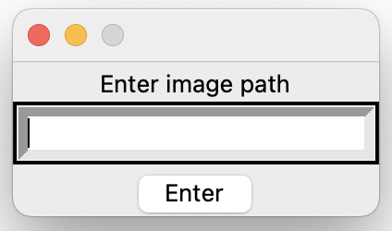

Main window

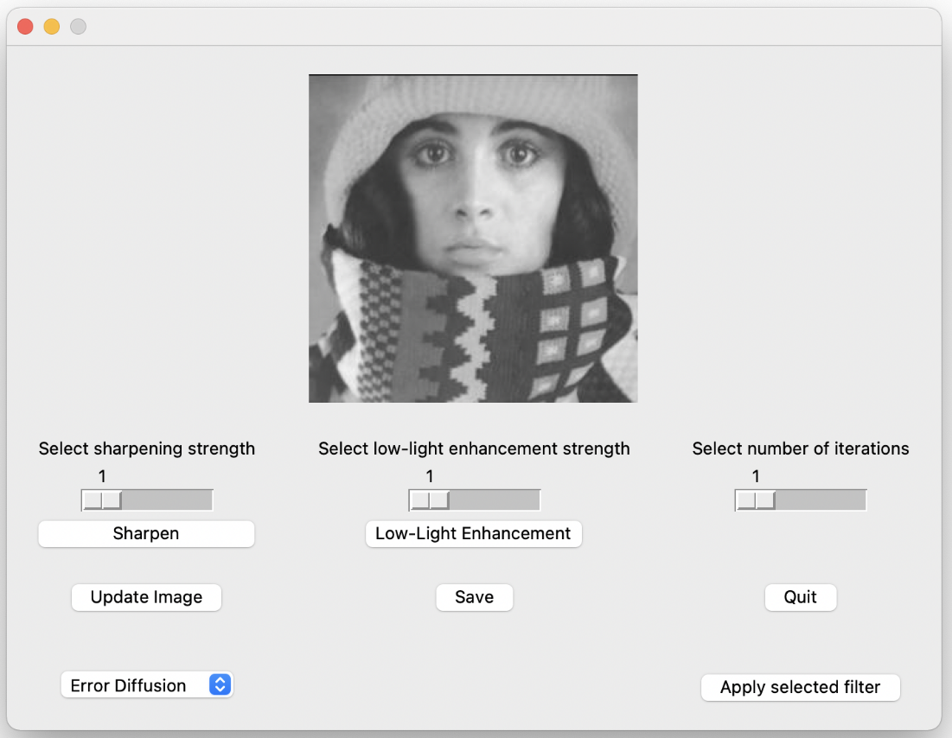

Save Image window

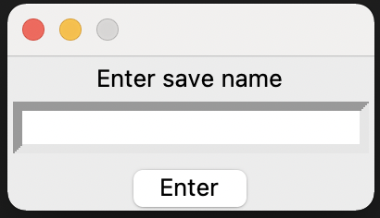

Update Image window



Invalid path window

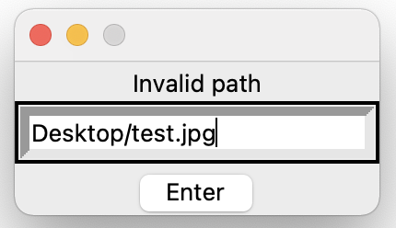

Invalid file type window

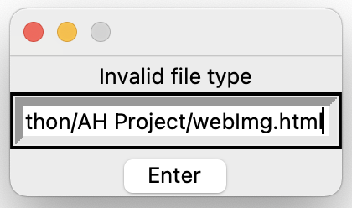

Research of new skills

For this project I had to learn multiple new skills that were not part of the AH computing course.

1. Using PIL, a library which adds image processing capabilities to python. The PIL library was used to select an image from a file location. The program used PIL to open an image from a file location chosen by the user and to convert images from greyscale to RGB and from RGB to greyscale. This was essential to allow the user to select images from their device and to fix certain bugs discovered during the ongoing testing.
2. Using tkinter, a Python interface library. Tkinter was used to create the GUI of the program. The program used tkinter to create the windows, and all the buttons, sliders, input boxes and menus in them. Tkinter was used to receive input from the user and display output (filtered images and messages).
3. I needed to learn how to use 3d arrays as the program had to convert RGB images into 3d arrays. The program used 3d arrays to apply filters as the filter algorithms were applied to arrays.
4. Using numpy, a library which is used to create and work with multi-dimensional arrays. I used numpy to convert images into 2d and 3d arrays. This was essential as the program applied filter algorithms to images as arrays. It was also used to convert the arrays into images.
5. Using the OS library, which is used to interact with the operating system. I used this library to check if paths existed on the user’s device. This allowed me to add validation which ensures that the user could only enter paths that were existing image files.
6. Using the imghdr library which can determine the type of an image. This library allowed me to check the file type of the file selected by the user to ensure that it is an image file.
7. Using the anonymous function, which is a function that can have any number of arguments but only one expression. This was used to fix a bug discovered during the ongoing testing.

Log of Ongoing Testing

|  |  |  |
| --- | --- | --- |
| **ISSUE** | **RESOLUTION OF ISSUE** | **REFERENCE** |
| Applying Sharpen filter to a RGB image results in an error. | This was caused by the program attempting to convert an image with 3 color channels into a 2d array.  Image that is being edited is now converted into a 3d array instead of a 2d array. |  |
| The buttons which are meant to call a method when clicked instead do nothing. | Making the function that runs when the button is clicked an anonymous function. | https://realpython.com/python-lambda/ |
| Applying Improve Image filter to a RGB image results in an error. | This was caused by the program attempting to convert an image with 3 color channels into a 2d array.  Image that is being edited is now converted into a 3d array instead of a 2d array. |  |
| Applying Sharpen or Improve Lighting filter results in a black image. | Array should be converted to a uint8 type array before it is converted into an image. | https://numpy.org/doc/stable/user/basics.types.html |
| After Sharpen filter is applied, resultant image has colorful blotches in the middle. | This was caused by values in the images array being greater than 1 or less than 0, resulting in colorful blotches.  The array is trimmed before it is converted into an image. Any value greater than 1 was set to 1 and any value less than 0 was set to 0. |  |
| Applying Sharpen filter to grayscale image results in an error. | This was caused by the program attempting to convert an image with 2 color channels into a 2d array.  Image is converted to RGB before the filter is applied. |  |
| Applying Error Diffusion or Median Filter filters to an RGB image results in an error. | This was caused by the program attempting to convert an image with 3 color channels into a 2d array.  Image is now converted to grayscale before being converted into an array. |  |
| Updated image not being displayed in the Main window. | This was caused by the variable which stored the image not being global.  The variable which stores the image is now set to global. |  |
| Selecting a new image using Update Image displays a new image in the Main window but applying any filter would apply the filter to the old image. | The Update Image method was not passing on the new image selected by the user to any other methods.  The Update Image method now passes on the new image selected by the user. |  |

Testing of the Solution

Design of Test Data

**Startup**

|  |  |  |  |
| --- | --- | --- | --- |
| **TESTING DESCRIPTION** | **INPUT** | **EXPECTED RESULT** | **REASON FOR TESTING** |
| Start the program using run in Visual Studio Code. |  | The current date is written to the file “webImg.html” on the user’s device.  The Select Image window appears. | To check the program launches correctly. |

**Select Image**

|  |  |  |  |
| --- | --- | --- | --- |
| **TESTING DESCRIPTION** | **INPUT** | **EXPECTED RESULT** | **REASON FOR TESTING** |
| Open the Select Image window by starting the program using run in Visual Studio Code. |  | The Select Image window appears, displaying the following:   * A message prompting the user to enter the path of the image they wish to use * An input box * An enter button | To check that the Select Image window is created correctly. |
| Enter a path which is not an existing file. | Path entered in input box.  Enter button clicked. | A message is displayed stating that the path is invalid. | To check that the input validation denies any invalid inputs. |
| Enter a path which is a file, but not a PNG, JPG or BMP file. | Path entered in input box.  Enter button clicked. | A message is displayed stating that the file type is invalid. | To check that the input validation denies any invalid file types. |
| Enter a path which is a PNG, JPG or BMP file. | Path entered in input box. Enter button clicked. | The Select Image window is closed.  The Main window appears, displaying the image at the file location entered by the user. | To check that the user can select an image from his device. |
| Enter a path which is an image with a width and height greater than 500 pixels. | Path entered in input box. Enter button clicked. | The Select Image window is closed. The Main window appears, displaying a scaled version of the image at the file location entered by the user. | To check that if a selected image is too big, it is scaled down before being displayed. |

**Main Image Editor**

|  |  |  |  |
| --- | --- | --- | --- |
| **TESTING DESCRIPTION** | **INPUT** | **EXPECTED RESULT** | **REASON FOR TESTING** |
| Open the Main window. |  | Main window opens displaying the following:   * The image selected by the user. * A Sharpen button * An Improve Lighting button * A sharpening strength slider with values from 1 to 20 * A low-light enhancement slider with values from 1 to 20 * A number of iterations slider with values from 1 to 5 * Labels above the sliders * An Update Image button * A Save button * A Quit button * A drop-down menu containing two options Error Diffusion and Median Filter * An Apply Selected Filter button. | To check that the Main window is created correctly. |
| Apply the Sharpen filter to a blurry image. | Sharpen button clicked. | The image becomes sharper. The filtered image is displayed in the Main window. | To check that the program can correctly apply the Sharpen filter and display the result. |
| Apply the Low-Light Enhancement filter to a low-light image. | Low-Light Enhancement button clicked. | The dark parts of the image become more intense. The filtered image is displayed in the Main window. | To check that the program can correctly apply the Low-Light Enhancement filter and display the result. |
| Apply the Sharpen filter to an image adjusting the value selected by the sharpening strength slider. | Value selected using sharpening strength slider.  Sharpen button clicked. | The greater the value selected by the slider, the greater the strength of the sharpening filter. | To check that the sharpening intensity can be adjusted. |
| Apply the Low-Light Enhancement filter to an image adjusting the value selected by the low-light enhancement strength slider. | Value selected using low-light enhancement strength slider.  Improve Lighting button clicked. | The greater the value selected by the slider, the greater the strength of the low-light enhancement filter. | To check that the lighting improvement intensity can be adjusted. |
| Apply the Sharpen and Low-Light Enhancement filters to an image adjusting the value selected by the number of iterations slider. | Value selected using number of iterations slider.  Sharpen/Low-Light Enhancement button clicked. | The value selected by the slider determines how many times the chosen filter is applied. | To check that the number of iterations can be adjusted. |
| Apply the Error Diffusion filter to an image. | Error Diffusion selected using the drop-down menu. Apply selected filter button clicked. | The image is converted into a binary image. The filtered image is displayed in the Main window. | To check that the program can correctly apply the error diffusion filter and display the result. |
| Apply the Median filter to a noisy image. | Median Filter selected using the drop-down menu. Apply selected filter button clicked. | The image becomes less noisy. The filtered image is displayed in the Main window. | To check that the program can correctly apply the median filter and display the result. |
| Input an unsorted array of 9 integers into the median bubble sort algorithm. | Unsorted array of 9 integers. | The median of the array is returned. | To check that the bubble sort algorithm in the Median Filter works correctly. |
| Click the Quit button | Quit button clicked. | All windows are closed, and the program is terminated. | To check that the program can be exited with the Quit button. |
| Click the Update Image button. | Update Image button clicked. | The Update Image window appears. | To check that the Update Image window can be opened with the Update Image button. |
| Click the Save Image button. | Save Image button clicked. | The Save Image window appears. | To check that the Save Image window can be opened with the Save Image button. |

**Update Image**

|  |  |  |  |
| --- | --- | --- | --- |
| **TESTING DESCRIPTION** | **INPUT** | **EXPECTED RESULT** | **REASON FOR TESTING** |
| Open the Update Image window by clicking the Update Image button. | Update Image button clicked. | The Update Image window appears, displaying the following:   * A message prompting the user to enter the path of the image they wish to use * An input box   An enter button | To check that the Update Image window is created correctly. |
| Enter a path which is not an existing file. | Path entered in input box.  Enter button clicked. | A message is displayed stating that the path is invalid. | To check that the input validation denies any invalid inputs. |
| Enter a path which is a file, but not a PNG, JPG or BMP file. | Path entered in input box.  Enter button clicked. | A message is displayed stating that the file type is invalid. | To check that the input validation denies any invalid file types. |
| Enter a path which is a PNG, JPG or BMP file. | Path entered in input box. Enter button clicked. | The Update Image window is closed.  The Main window updates, displaying the image at the file location entered by the user. | To check that the user can replace the current image with another image from his device. |
| Enter a path which is an image with a width and height greater than 500 pixels. | Path entered in input box. Enter button clicked. | The Update Image window is closed. The Main window updates, displaying a scaled version of the image at the file location entered by the user. | To check that if a selected image is too big, it is scaled down before being displayed. |

**Save Image**

|  |  |  |  |
| --- | --- | --- | --- |
| **TESTING DESCRIPTION** | **INPUT** | **EXPECTED RESULT** | **REASON FOR TESTING** |
| Open the Save Image window. |  | Save Image window appears, displaying the following:   * A message prompting the user to enter the name under which they would like to save the image * An input box * An enter button | To check that the Save Image window is created correctly. |
| Save the image under a name selected by the user. | Name entered in input box  Enter button clicked. | The image is saved as a PNG file to the same directory as the program. It is under the name selected by the user.  The image is saved to the html file “webImg.html” under the current date.  The Save Image window is closed. | To check if images can be saved to the user's device and if images can be saved to the webpage. |

**Testing using test data**

**Startup**

|  |  |  |
| --- | --- | --- |
| **TESTING DESCTRIPTION** | **EXPECTED RESULT** | **ACTUAL RESULT** |
| Program is started using run in Visual Studio Code. | The current date is written to the file “webImg.html” on the user’s device.  The Select Image window appears. | The current date is written to the file “webImg.html”.  The Select Image window appears. |



webImg.html after starting the program

**Select Image**

|  |  |  |
| --- | --- | --- |
| **TESTING DESCRIPTION** | **EXPECTED RESULT** | **ACTUAL RESULT** |
| Open the Select Image window by starting the program using run in Visual Studio Code. | Select Image window appears, matching the design and displaying the following:   * A message prompting the user to enter the path of the image they wish to use * An input box * An enter button | The Select Image window appears.  The Select Image window’s user interface matches the expected result and the design. |
| Enter “Desktop/test.jpg”, a path which is not an existing file on the testing device, in the input box and click enter. | A message is displayed stating that the path is invalid. | A message is displayed stating that the path is invalid. |
| Enter a path which is an html file on the testing device into the input box and click enter. | A message is displayed stating that the file type is invalid. | A message is displayed stating that the file type is invalid. |
| Enter a path which is a JPG image on the testing device into the input box and click enter.  The JPG image used | The Select Image window is closed.  The Main window appears, displaying the image that has the path entered by the user | The Select Image window is closed.  The Main window appears, displaying the image that has the path entered in the input box. |
| Enter a path which is a JPG image with dimensions 3840x2160 into the input box and click enter.  The JPG image used | The Select Image window is closed.  The image that the path entered is scaled down.  The Main window appears, displaying a scaled version of the image at the file location entered. | The Select Image window is closed.  The Main window appears, displaying a scaled version of the image that has the path entered in the input box. |

**Main Image Editor**

|  |  |  |
| --- | --- | --- |
| **TESTING DESCRIPTION** | **EXPECTED RESULT** | **ACTUAL RESULT** |
| Select an image and open the Main window. | Main window opens, matching the design and displaying the following:   * The image selected by the user. * A Sharpen button * An Improve Lighting button * A sharpening strength slider with values from 1 to 20 * A low-light enhancement slider with values from 1 to 20 * A number of iterations slider with values from 1 to 5 * Labels above the sliders * An Update Image button * A Save button * A Quit button * A drop-down menu containing two options Error Diffusion and Median Filter * An Apply Selected Filter button. | The Main window opens, displaying the selected image.  The Main window’s user interface matches the expected result and the design. |



**Sharpen testing**

**Testing Description**

Select a blurry image. Set the sharpening strength to 5, and the number of iterations to 2. Apply the Sharpen filter to the image by clicking the Sharpen button. Compare the original image with the filtered image.

**Expected Result:**

The image becomes sharper. The sharpened image is displayed in the Main window.

**Actual Result:**

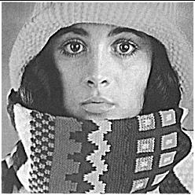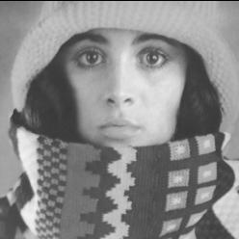 Blurry Image Sharpen filter applied

The image becomes sharper after the filter is applied. The updated image is displayed in the Main window.

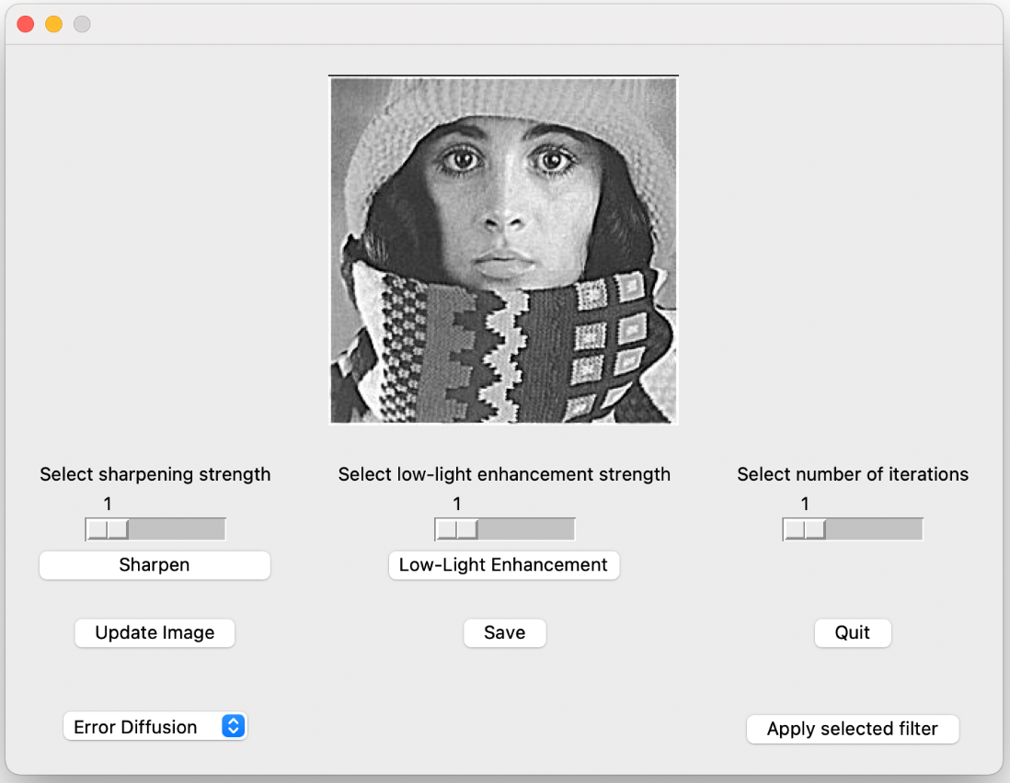

The filtered image displayed in the Main window

**Improve Lighting testing**

**Testing Description:**

Select an image with bad lighting. Set the low-light enhancement strength to 5, and the number of iterations to 2. Apply the Low-Light Enhancement filter to the image by clicking the Low-Light Enhancement button. Compare the original image with the filtered image.

**Expected Result:**

The darker parts of the image become more intense. The updated image is displayed in the Main window.

**Actual Result:**

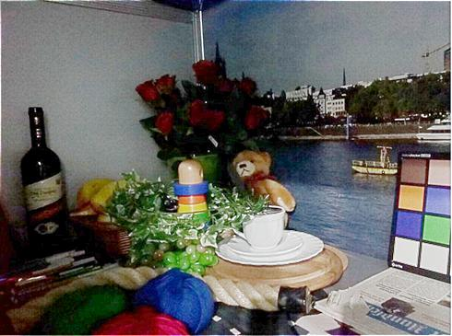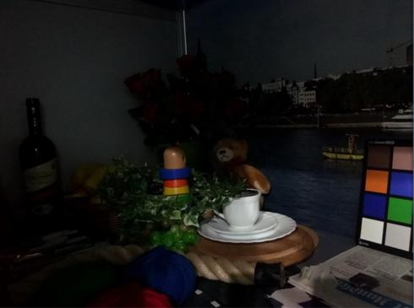 Image with bad lighting Low-Light Enhancement filter applied

The darker parts of the image become more intense after the filter is applied. The updated image is displayed in the Main window.

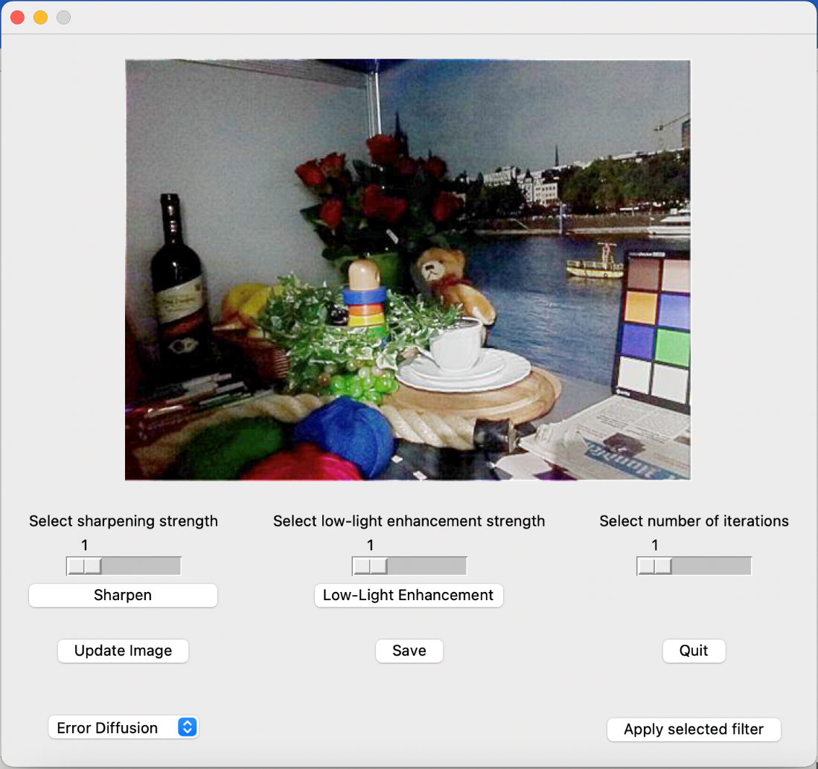

The filtered image displayed in the Main window

**Error Diffusion testing**

**Testing Description:**

Select an image. Select Error-Diffusion from the drop-down menu. Apply the filter by clicking the Apply selected filter button. Compare the original image with the filtered image

**Expected Result:**

The resultant image is a binary image. It is displayed in the Main window.

**Actual Result:**

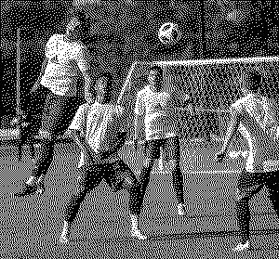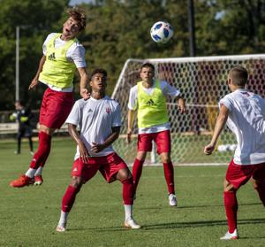

Original image Error Diffusion filter applied

The resultant image is a binary image. The updated image is displayed in the Main window.

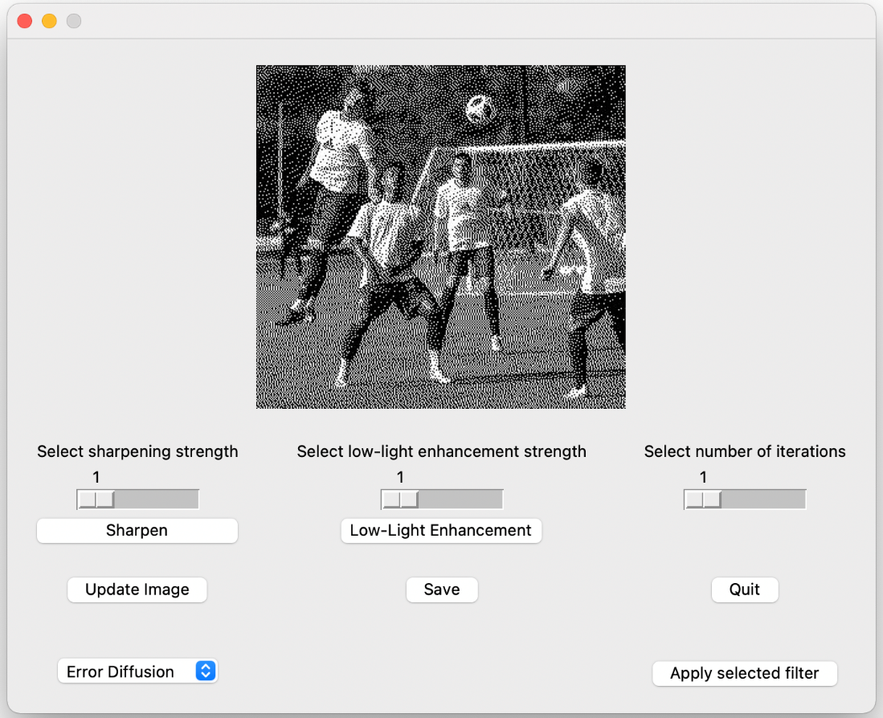

The filtered image displayed in the Main window

**Median Filter testing**

**Testing Description**

Select a noisy image. Select Median Filter from the drop-down menu. Apply the filter by clicking the Apply selected filter button. Compare the original image with the filtered image.

**Expected Result:**

The resultant image will have less noise. The updated image is displayed in the Main window.

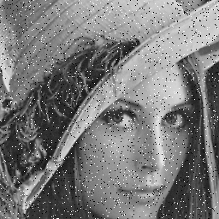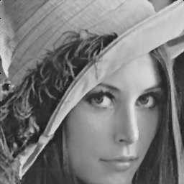

Image with salt & pepper noise Median Filter applied

The resultant image is less noisy. The updated image is displayed in the Main window.

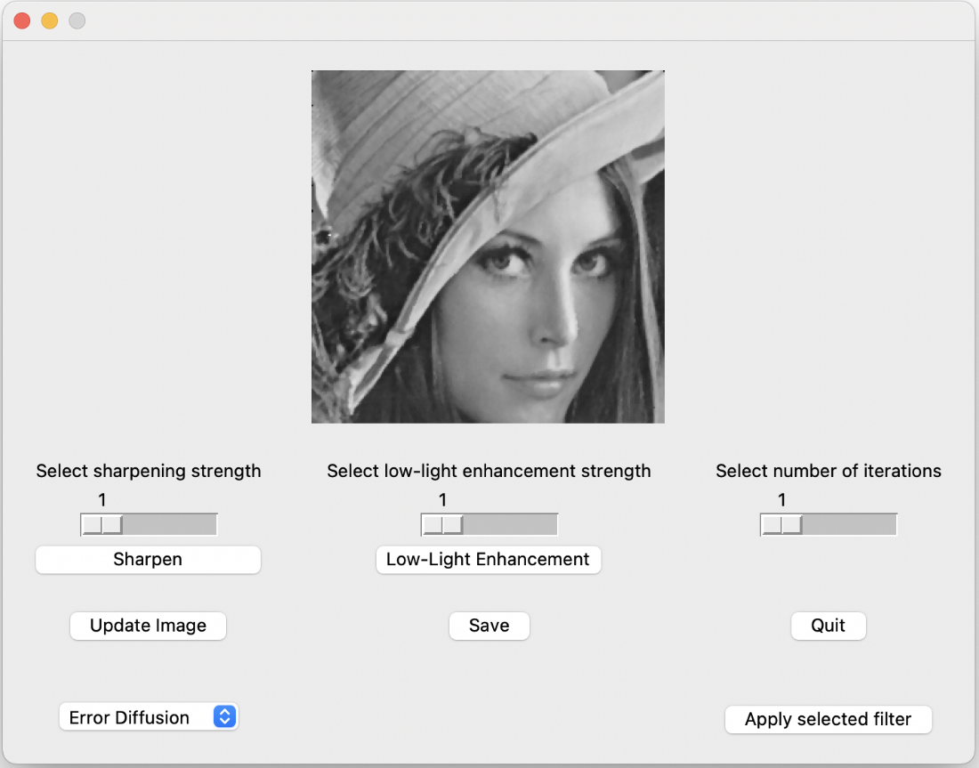

The filtered image displayed in the Main window

|  |  |  |
| --- | --- | --- |
| **TESTING DESCRIPTION** | **EXPECTED RESULT** | **ACTUAL RESULT** |
| Input an unsorted array of 9 integers into the median method’s bubble sort algorithm. Run the median method and print the output  Array used: [11, 101, 34, 62, 2, 3, 86, 7, 59] | 34 is printed in the terminal. | 34 is printed in the terminal. |

Excerpt of testing code:

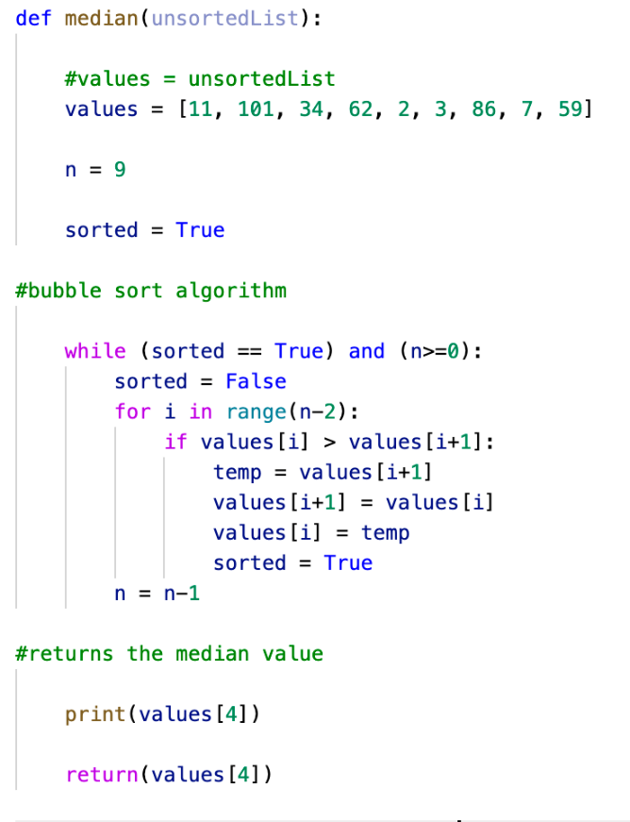

The input used is the array from the testing description, and the median is printed.

|  |  |  |
| --- | --- | --- |
| **TESTING DESCRIPTION** | **EXPECTED RESULT** | **ACTUAL RESULT** |
| Apply the Sharpen filter to an image with the sharpening strength slider set to 5. Print the sharpening strength variable. Apply the Sharpen filter to the same image with the sharpening strength slider set to 15. Print the sharpening strength variable. | The image sharpened with a greater sharpening strength value selected is sharper. The sharpening strength variable that is printed is the same as the value selected by the slider. | Setting the sharpening strength slider to 15 results in a sharper image than if the sharpening strength slider was set to 5.  The printed value is the same as the value selected by the slider. |

Excerpt of testing code:

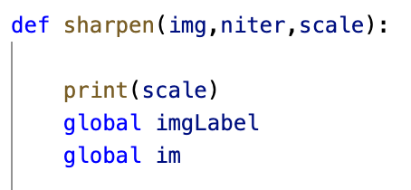

The sharpening strength variable is printed at the beginning of the sharpen method.

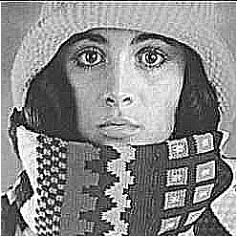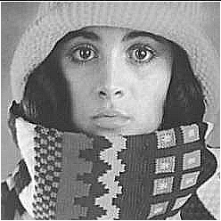

Sharpening strength set to 5 Sharpening strength set to 15

The image that was sharpened with a greater sharpening strength selected has had a more intense sharpening filter applied to it.

|  |  |  |
| --- | --- | --- |
| **TESTING DESCRIPTION** | **EXPECTED RESULT** | **ACTUAL RESULT** |
| Apply the Low-Light Enhancement filter to an image with the low-light enhancement strength slider set to 5. Print the low-light enhancement strength variable. Apply the Low-Light Enhancement filter to the same image with the low-light enhancement strength slider set to 15. Print the low-light enhancement strength variable. | The image enhanced with a greater low-light enhancement strength value selected has been intensified more. The low-light enhancement variable is the same as the value selected by the slider. | The value selected by the low-light enhancement filter did not affect how much the image had been intensified.  The printed value is the same as the value selected by the slider. |

Excerpt of testing code:

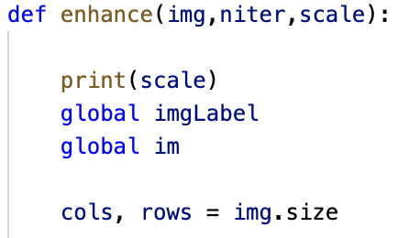

The low-light enhancement strength variable is printed at the beginning of the enhance method.

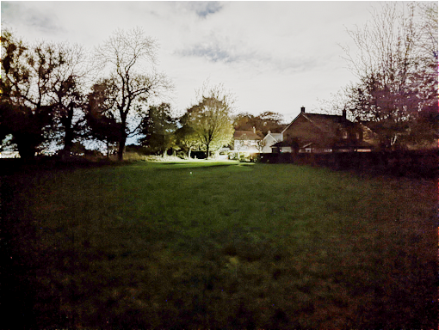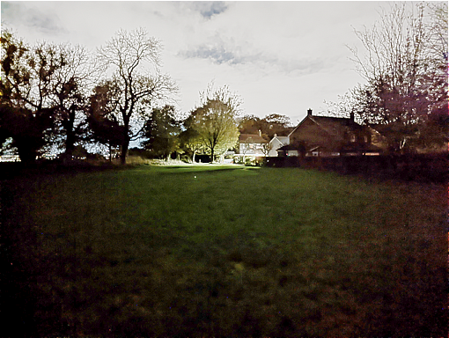

Low-light enhancement strength set to 5 Low-light enhancement strength set to 15

The images are identical. The low-light enhancement strength had no effect on the strength of the Low-Light Enhancement filter.

|  |  |  |
| --- | --- | --- |
| **TESTING DESCRIPTION** | **EXPECTED RESULT** | **ACTUAL RESULT** |
| Apply the Sharpen and Low-Light Enhancement filters to an image adjusting the value selected by the number of iterations slider. Print the number of iterations variable.  The number of iterations slider is set to values from 1 to 5 for both filters. | The printed variable matches the value selected by the number of iterations slider for both filters. | The printed variable is the same as the value selected by the number of iterations slider for both filters. |

Excerpts of testing code:

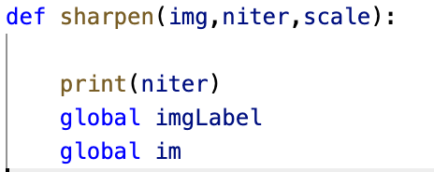

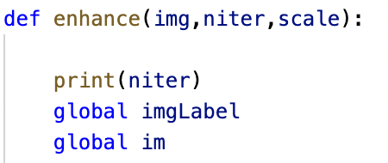

The number of iterations variable at the start of the sharpen and enhance methods is printed.

|  |  |  |
| --- | --- | --- |
| **TESTING DESCRIPTION** | **EXPECTED RESULT** | **ACTUAL RESULT** |
| Click the Quit button. | All windows are closed, and the program ends. | All windows are closed, and the program ends. |
| Click the Update Image button. | The Update Image window appears. | The Update Image window appears. |
| Click the Save Image button. | The Save Image window appears. | The Save Image window appears. |

**Update Image**

|  |  |  |
| --- | --- | --- |
| **TESTING DESCRIPTION** | **EXPECTED RESULT** | **ACTUAL RESULT** |
| Open the Update Image window by clicking the Update Image button. | Update Image window appears, matching the design and displaying the following:   * A message prompting the user to enter the path of the image they wish to use * An input box * An enter button | The Update Image window appears.  The Update Image window’s user interface matches the expected result and the design. |
| Enter “Desktop/test.jpg”, a path which is not an existing file on the testing device, in the input box and click enter. | A message is displayed stating that the path is invalid. | A message is displayed stating that the path is invalid. |
| Enter a path which is an html file on the testing device into the input box and click enter. | A message is displayed stating that the file type is invalid. | A message is displayed stating that the file type is invalid. |
| Enter a path which is a JPG image on the testing device into the input box and click enter.  The JPG image used | The Update Image window is closed.  The Main window displays the image that has the path entered by the user. | The Update Image window is closed.  The Main window displays the image that has the path entered in the input box. |
| Enter a path which is a JPG image with dimensions 3840x2160 into the input box and click enter.  The JPG image used | The Update Image window is closed.  The image that the path entered is scaled down.  The Main window displays a scaled version of the image at the file location entered. | The Update Image window is closed.  The Main window displays a scaled version of the image that has the path entered in the input box. |

**Save Image**

|  |  |  |
| --- | --- | --- |
| **TESTING DESCRIPTION** | **EXPECTED RESULT** | **ACTUAL RESULT** |
| Open the Save Image window by clicking the Save Image button. | Save Image window appears, displaying the following:   * A message prompting the user to enter the name under which they would like to save the image * An input box * An enter button | The Save Image window appears.  The Save Image window’s user interface matches the expected result and the design. |
| Enter “saveTest” into the input box then click enter. | The image that is being displayed in the Main window is saved to the same directory as the program under the name “saveTest” with the PNG file type.  The image is added to the html file “webImg.html” under the date current date.  The Save Image window is closed. | The image appears under the name “saveTest” and with the file type PNG in the same directory as the program.  The webpage displays the image under the current date. The webpage matches the design wireframe. The Save Image window is closed. |

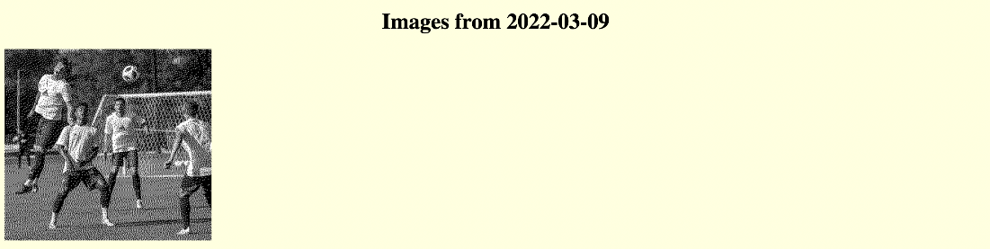

webImg.html after saving an image

Persona Testing

**Persona:**

A S6 student who needs to edit photos on his laptop for his photography class. He is proficient in using other similar image editors. He needs to select an image from his device, apply a filter to it then save the image to his device.

|  |  |
| --- | --- |
| **TEST CASE** | **DESCRIPTION OF TEST** |
| Launching the program and selecting an image from his device. | The user successfully launched the program and entered the path of the image he wished to use. The Select Image window opened. The user made a mistake when typing the path into the input box, so when he clicked enter a message appeared saying the path is invalid. The user fixed the error and clicked enter again. The Select Image window disappeared, and the Main window appeared displaying the image the user had chosen. |
| Selecting the Median Filter | The user clicked on the drop-down menu and selected Median Filter. |
| Applying for the Median Filter | The user clicked the Apply selected effect button. The image in the Main window changed to the image with a filter applied to it. |
| Saving the image | The user clicked the Save Image button. The Save Image window opened. The user entered the name under which he wanted to save the image and clicked the enter button. The Save Image window disappeared. The image appeared in the same directory as the program as a PNG file under the name chosen by the user. |
| Quitting the program | The user clicked the Quit button. All the windows closed, and the program stopped running. |

**Persona:**

A S5 pupil with a visual impairment. They want to use the toolkit’s filters to improve the quality of their photos to make them easier to see. The user wants to apply the sharpen filter to a blurry image and save it to a webpage.

My program does not support text to speech, so unfortunately a user with a visual impairment would have difficulty or be unable to use this toolkit. However, if the user has a text to speech reader that works on websites, the text to speech reader could dictate the alternate text of images displayed on the webpage. Since the alternate text is the same as the name under which the image is saved, how useful this is depends on whether the person saving the image chose a relevant name.

Testing conclusion

During the testing phase, several bugs and errors were discovered and fixed. However, there is one bug I am unable to fix. The low-light enhancement strength slider does not affect the strength of the Low-Light Enhancement filter. I was unable to fix this bug as it requires more advanced knowledge of python.

Evaluation

Fitness for purpose

The result of the testing shows that the program is mostly fit for purpose. The low-light enhancement strength slider does not affect the strength of the Low-Light Enhancement filter. Since this was one of the functional requirements, not all the requirements have been met and the program is not completely fit for purpose.

**Startup Requirements – Completed**

**Select Image Requirements – Completed**

**Main Window Requirements – Mostly Completed**

* Low-light enhancement strength slider affects the strength of the Low-Light Enhancement filter requirement not met.

**Update Image Requirements – Completed**

**Save Image Requirements – Completed**

**End User Requirements – Completed**

Maintainability

The finished program is maintainable. The program is made up of subprograms. Meaningful names are used for the variables and methods. Commentary is used throughout the program to explain the function of different methods and variables. Indentation is used to increase the readability.

A line of hashtags is used to separate the different methods and also increase readability.



Due to the program's modularity and readability, it would be easy to expand on the image processing toolkit, adding different filters and parameters for the already existing filters.

Excerpt of code with commentary: 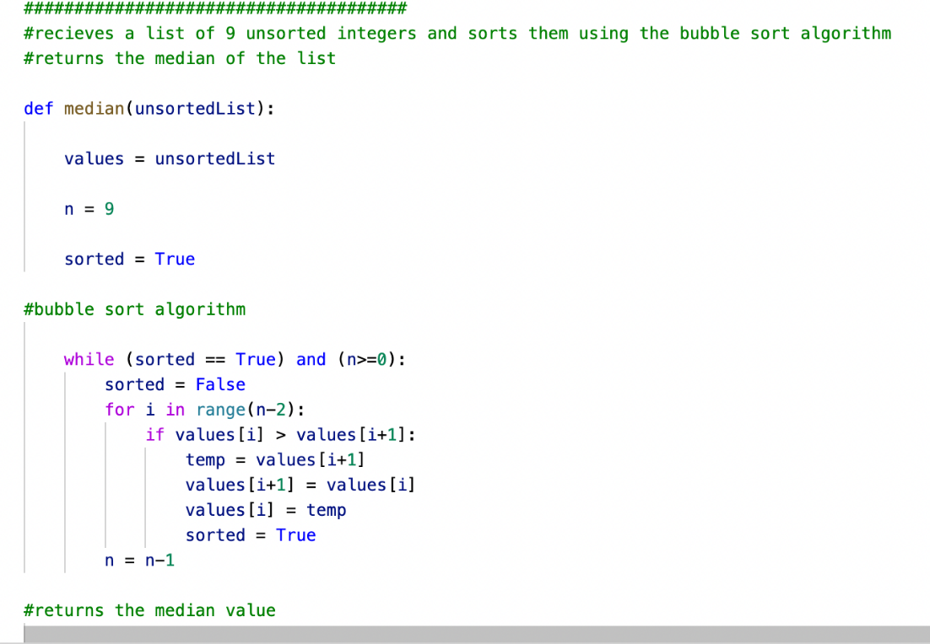

Robustness

The program is robust, as it has coped with the incorrect input given to it during testing. When selecting or updating the image they wish to use, the user is unable to enter a path which is not an existing file on their device or a path which is not an image file due to the validation. Here is a section of input validation code.

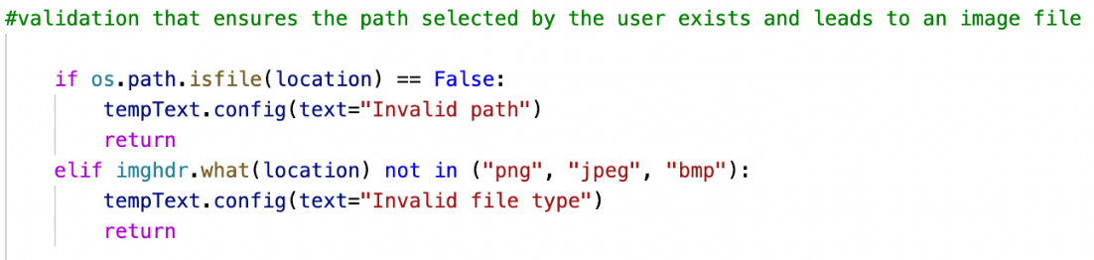

When selecting or updating the image they wish to use, if the user selects an image that is too big to be used, the image will be scaled down. Here is a section of the scaling code.

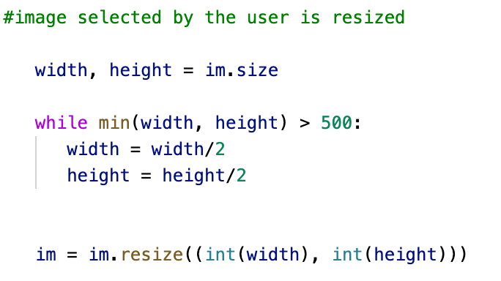

Results and Critical Analysis

I have successfully created a Python-based image processing toolkit, meeting all the end user requirements and all but one of the functional requirements. This toolkit successfully incorporates AH computing techniques and has pushed me to further my knowledge further by researching new skills. To further improve upon the toolkit, fix the bug related to the low-light enhancement strength slider, improve the UI as well as add new filters, such as a filter which improves image perception for the visually impaired, which would be easy to accomplish due to the program’s good maintainability.